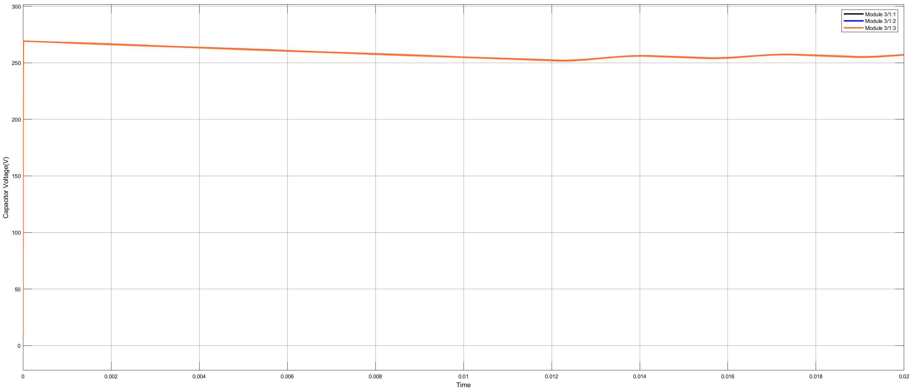

Figure 1 Capacitor Voltages

Capacitor voltages for each leg(phase) is almost equal at single module with rectifier.

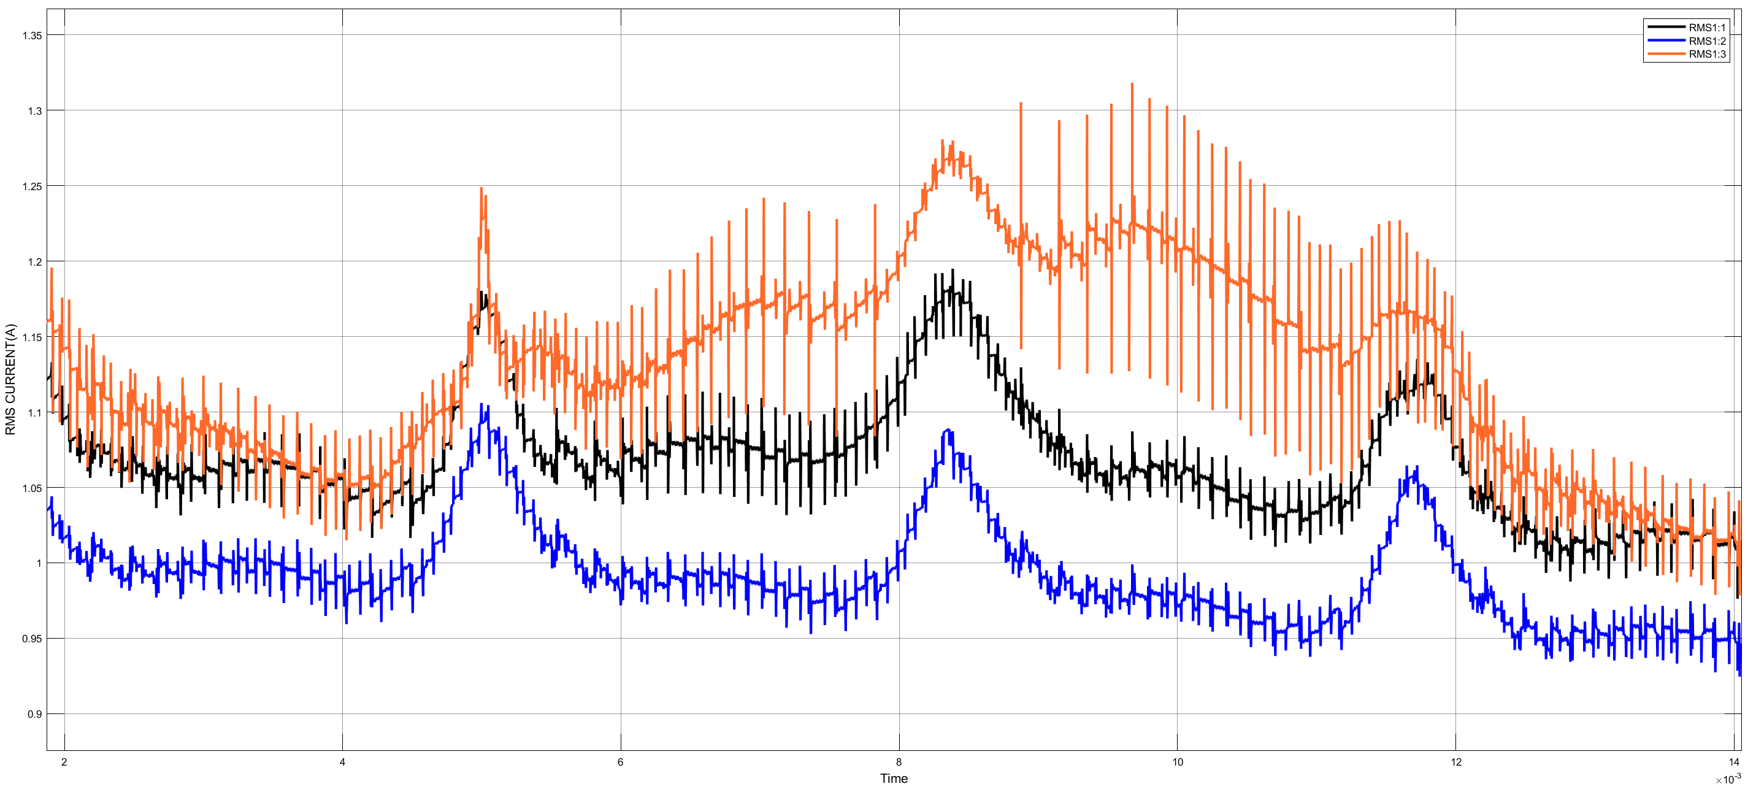

Capacitor rms current for each leg(phase), minimum value belongs to phase B???

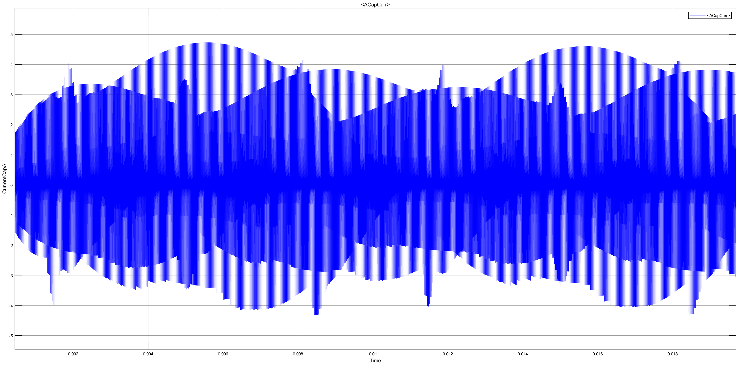

Capacitor phase A current ripple.

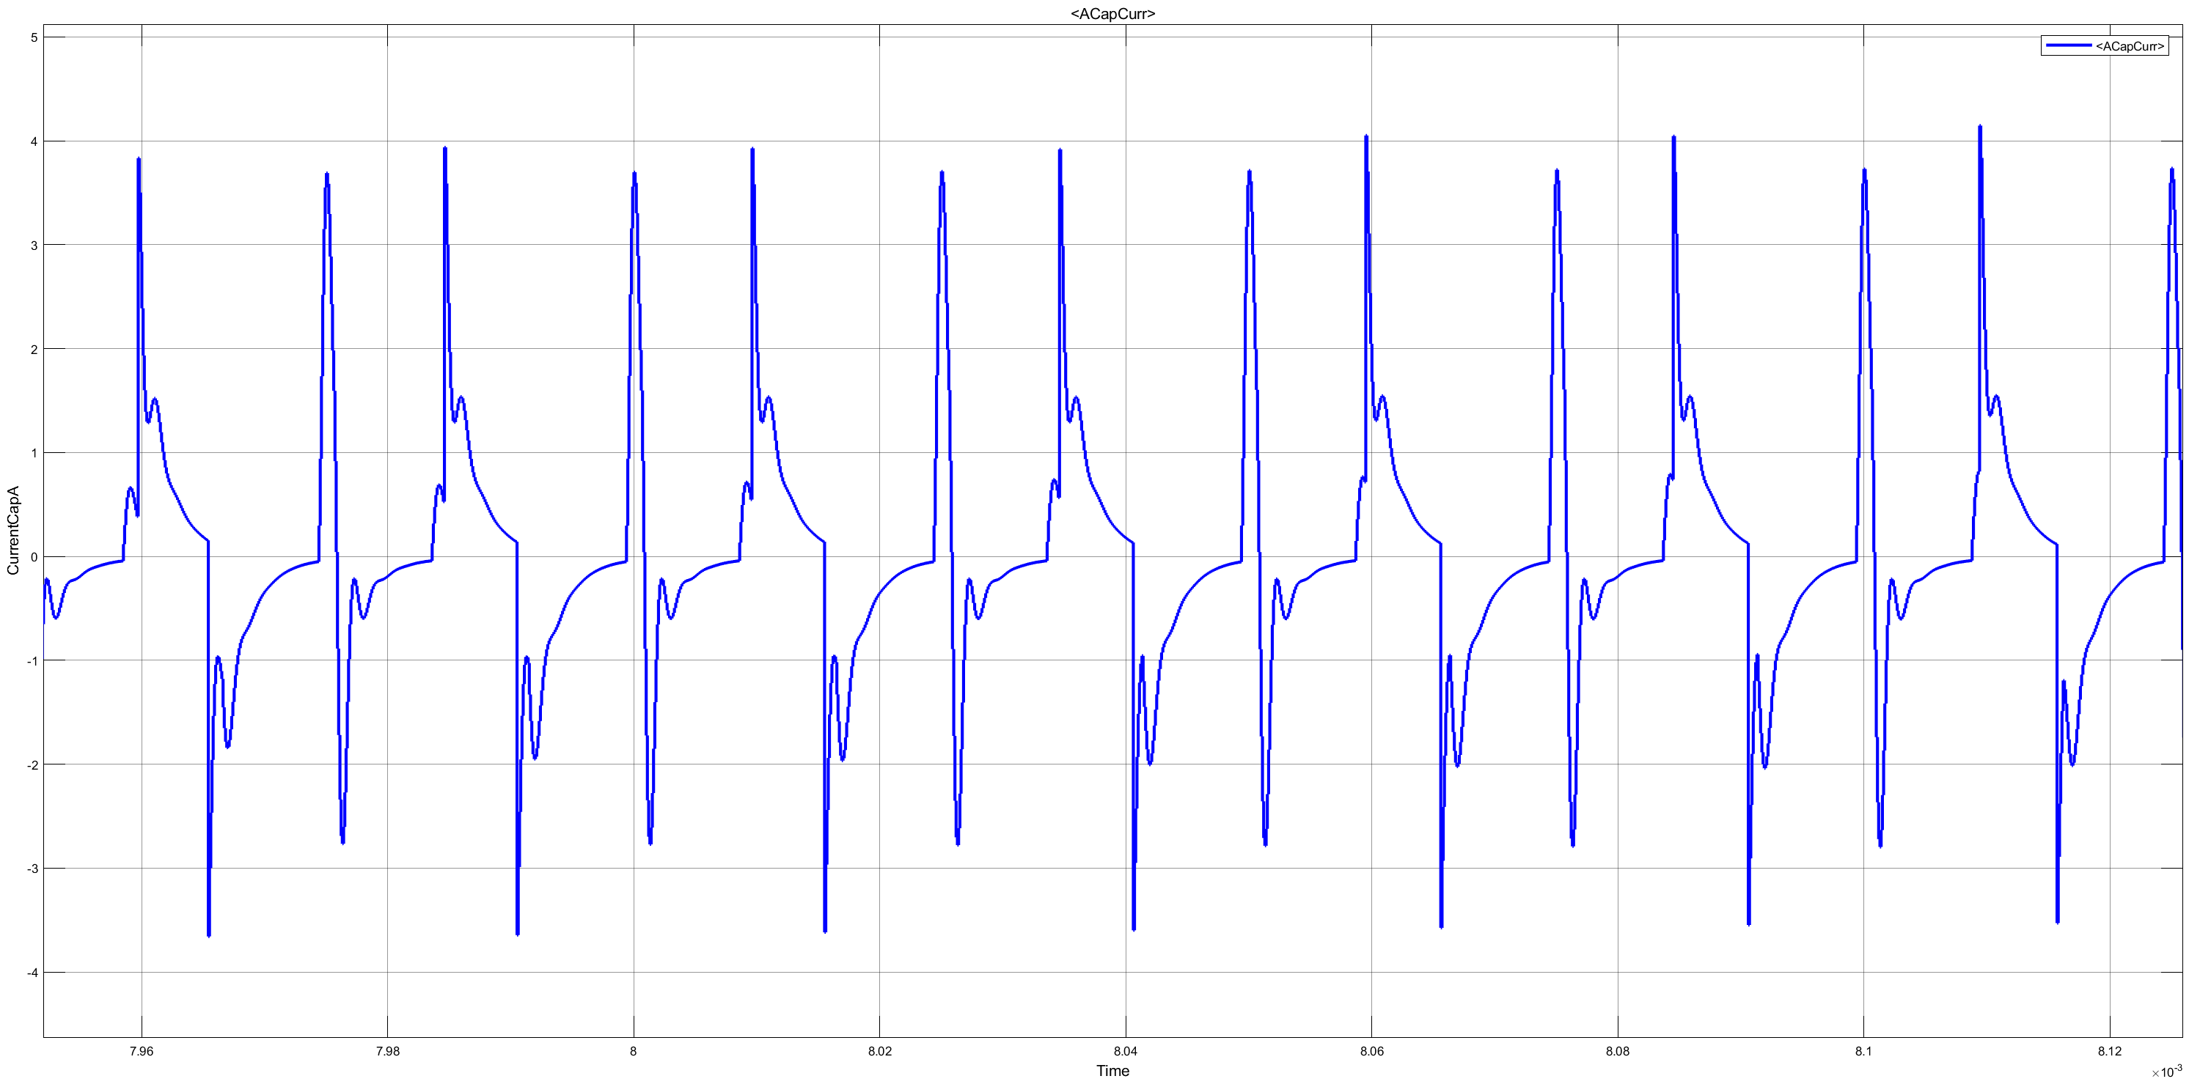

Capacitor phase A current ripple at close.



I export capacitor current to Matlab workspace. Above we can observe the capacitor ripple.



Looking close.

FFT Analysis (Magnitude for each phase capacitor at different figure)







FFT analysis(phase for each )

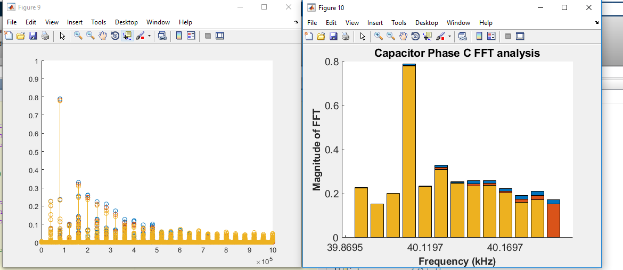

Xlabels are not valid. Actually, I put this image is only comment them. Before this, I found below 240 khz frequency part are almost the same. Stray or parasitic inductance is very small in range of nano henry and it changes the ripple above 250 kHz.